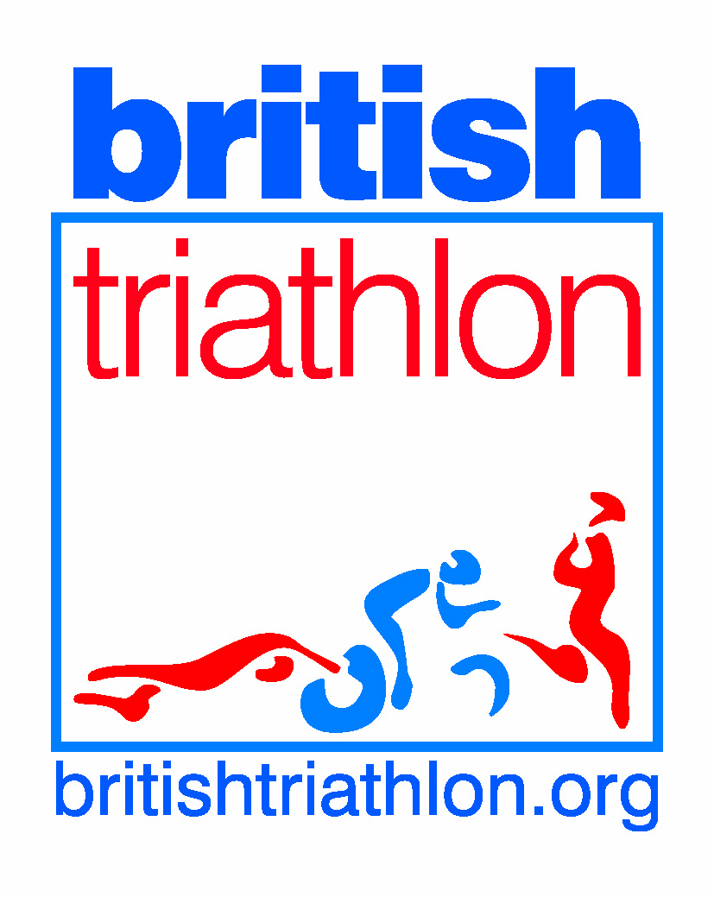

Equity Statement

Sports equity is about fairness in sport, equality of access, recognising inequalities and taking steps to address them. It is about changing the culture and structure of sport to ensure it becomes equally accessible to everyone in society.

Hereford Triathlon Club is committed to ensuring that equity is incorporated across all aspects of its development. In doing so it acknowledges and adopts the following British Triathlon and Sport England definition of sports equity:

The club respects the rights, dignity and worth of every person and will treat everyone equally within the context of their sport, regardless of age, ability, gender, race, ethnicity, religious belief, sexuality or social/economic status.

The club will endeavour where possible to reduce the barriers to participation that may arise based on an individual’s age, ability, gender, race, ethnicity, religious belief, sexuality or social/economic status.

The club is committed to everyone having the right to enjoy their sport in an environment free from threat of intimidation, harassment and abuse.

All club members and officials have a responsibility to oppose discriminatory behaviour and promote equality of opportunity.

The club will deal with any incidence of discriminatory behaviour seriously, according to club disciplinary procedures. All Incidences will be reported to the British Triathlon Federation Equity Manager for review.

The Club Welfare officer will be responsible for dealing with all matters of equity and will have attended the Running Sports Club for All workshop as a minimum requirement and will seek further guidance from the British Triathlon Equity Manager.

Signed on behalf of the Club Committee

Name____________________________ Position_________________________Date______

Name____________________________ Position_________________________Date______

